**Deep Learning Homework 2**

**1.Record the training and testing accuracy, plot the training loss curve and training accuracy curve in the report.**

**Softmax for MNIST Classification**

**Training**

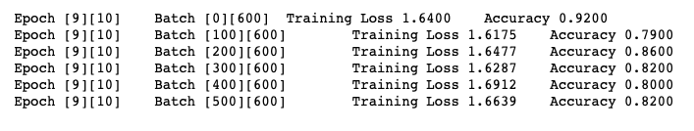

**Testing**

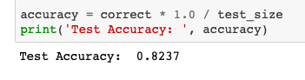

**Plot**

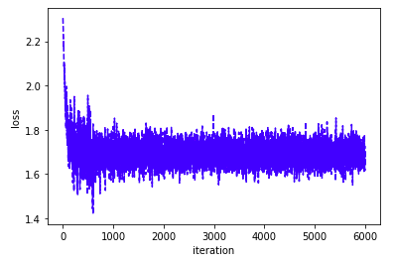 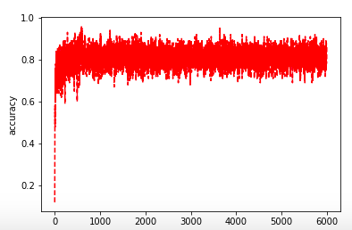

**1. MLP for MNIST Classification**

* 1. **MLP with Euclidean Loss and Sigmoid Activation Function**

**Training**



**Testing**

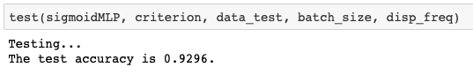

* 1. **MLP with Euclidean Loss and ReLU Activation Function**

**Training**



**Testing**

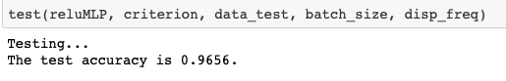

**Plot**

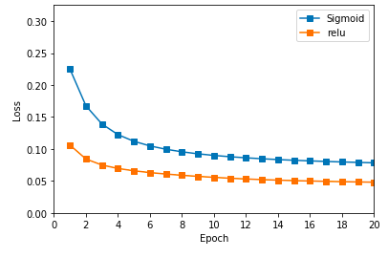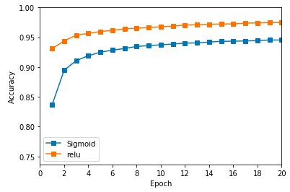

**2. MLP with Softmax Cross-Entropy Loss**

**2.1** **MLP with Softmax Cross-Entropy Loss and Sigmoid Activation Function**

**Training**



**Testing**

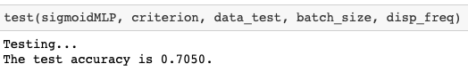

**2.2 MLP with Softmax Cross-Entropy Loss and ReLU Activation Function**

**Training**



**Testing**



**Plot**

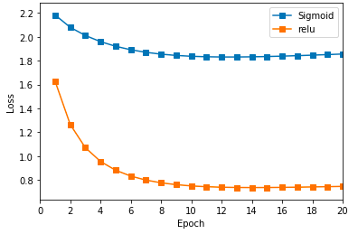 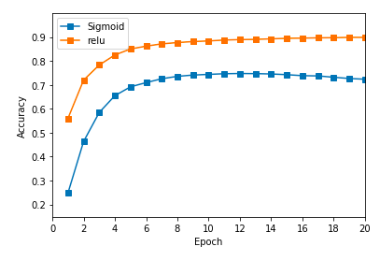

**Two-hidden-layer MLP**

**Softmax Cross-Entropy Loss and ReLU/ReLU Activation Function**

**Training**



**Testing**



**Plot**

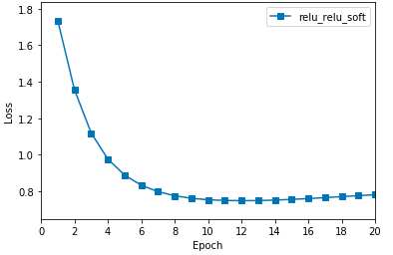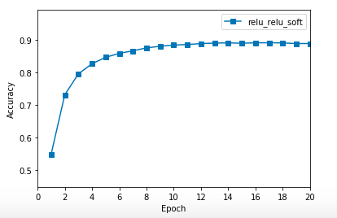

**2. The given hyerparameters maybe performed not very well. You can modify the hyerparameters**

**by your own, and observe how does these hyerparameters affect the classification**

**performance. Write down your observation and record these new results in the report.**

My hyperparameters performed reasonably well so I didn’t have the need to change it.

**3.Compare the difference of results when using Sigmoid and ReLU as activation function**

**(you can discuss the difference from the aspects of training time, convergence and accuracy).**

**Euclidean Loss**

 

**Softmax Cross-Entropy Loss**

 

3.As you can see from above Relu performed better in both Euclidean and Softmax Cross Entropy Loss than Sigmoid.

**4.Compare the difference of results when using EuclideanLoss and SoftmaxCrossEntropy-**

**Loss as loss function**

4.The highest accuracy rate 0.9656 was achieved by using MLP wıth Euclidean Loss and Relu Activation function. The lowest was 0.7050 with Softmax Cross-Entropy Loss and Sigmoid Activation Function. When we compare the results between Euclidean and Softmax Cross Entropy we can see that Euclidean performed better with both Sigmoid and Relu.

**5.Construct a MLP with two hidden layers (choose the number of hidden units by your own), using any activation function and loss function. Also, compare the difference of results between one-layer structure and two layers structure.**

I chose to compute the MLP two hidden layers with Softmax Cross-Entropy Loss and ReLU/ReLU Activation Function. As a result, it performed better than our worst result but at the end it wasn’t the best but overall it performed really well and maybe if I had played with the hyperparameters or tried a different two hidden layer it would have performed better.